Operation Lead
Netdata: http://192.168.0.230:19999
FossBilling admin: http://192.168.0.195/admin
FossBilling client: http://192.168.0.195
Commands used: reboot - restarted the proxmox server,
apt install apache2-utils,
ab -n 100 -c 10 http://192.168.0.195
Issues: ssl certification error returning invalid
Improvements: fix ssl error by removing netdata hostname from hosts, and hostname
Performance testing results:
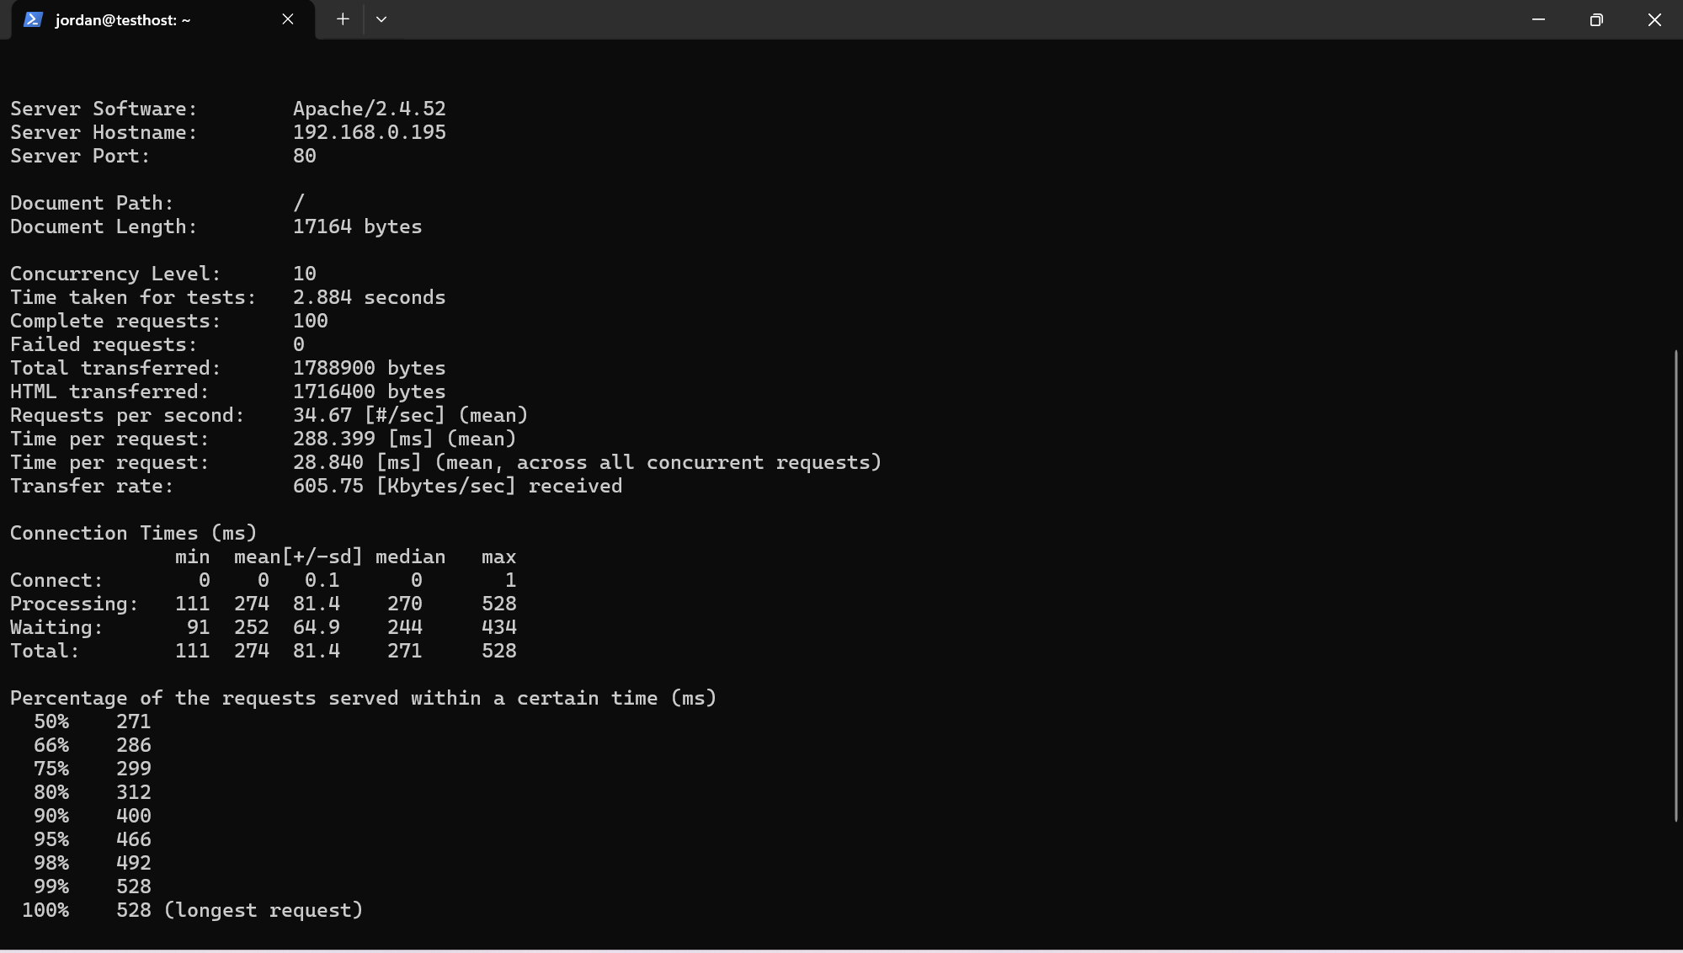
FossBilling VM SSH login/passwd: ubuntu@192.168.0.195 - shwki12345
Emails/passwd Fossbilling admin:
Braden -btcooper@gmail.com Bb12345678 / will change
Jordan -jordansteele1316@gmail.com Jj12345678 / will change
Donovan -Donovan@gmail.com Dd12345678 / will change
Shwki -shwki@gmail.com Shwki12345
Test/dummy Fossbilling client email/passwd:
- Name - Ahmed
User - Ahmed@gmail.com
Pass - Aa12345678
- Name - Jordan
User - Jordan@gmail.com
Pass - Jj12345678
- Name - Faruk
User - Faruk@gmail.com
Pass: Ff12345678

